INEQUALITIES
Pearson Edexcel - Thursday 6 June 2019 - Paper 2 (Calculator) Foundation Tier

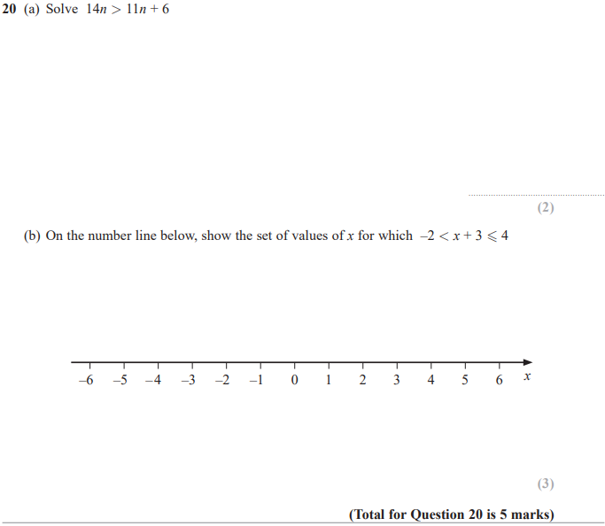

Pearson Edexcel - Monday 12 November 2018 - Paper 3 (Calculator) Foundation Tier

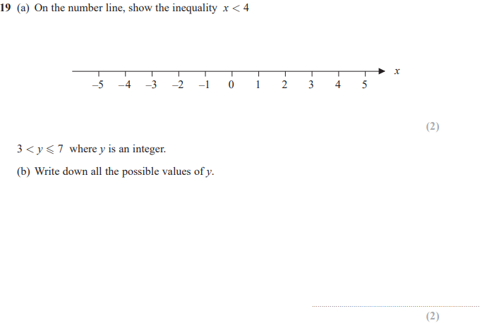
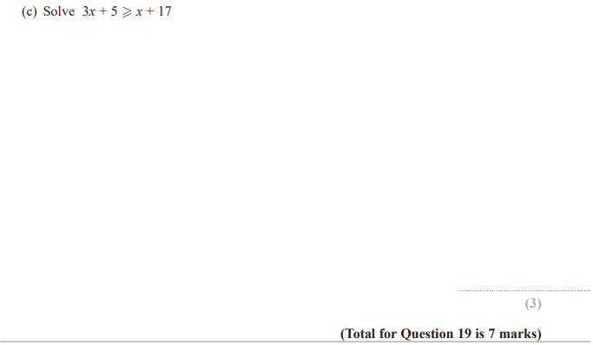

Pearson Edexcel – Specimen 2 - Paper 3 (Calculator) Foundation Tier

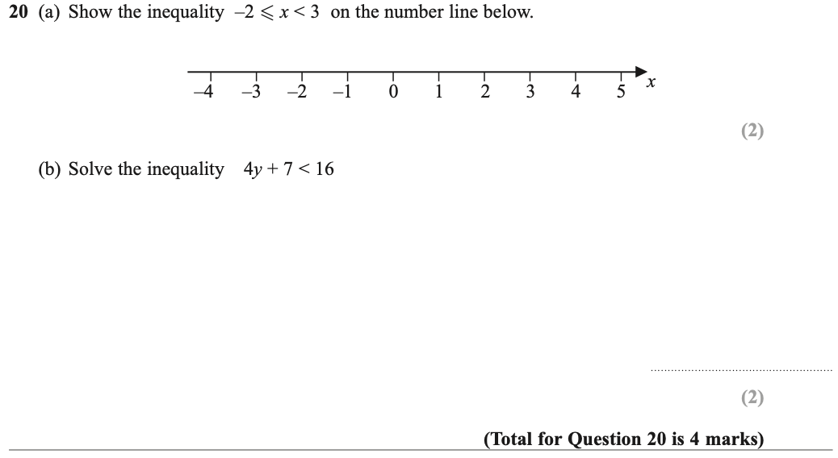

OCR November 09 November 2020- Morning (Calculator) Foundation Tier
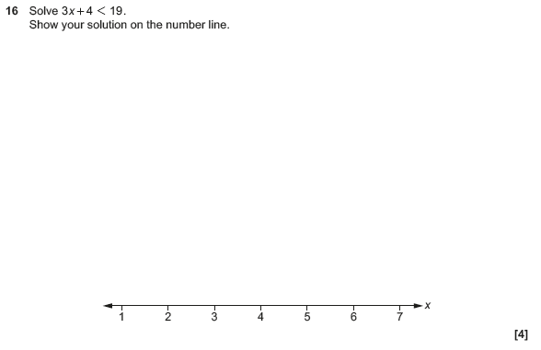

OCR Tuesday 5 November 2019 – Morning (Calculator) Foundation Tier
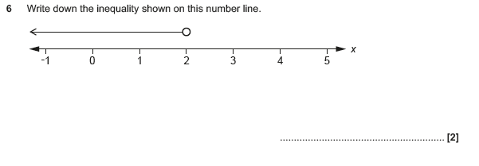

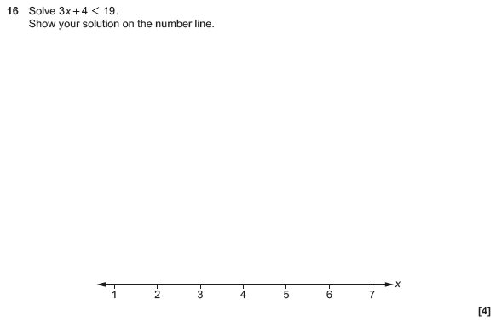

OCR Monday 11 November 2019 – Afternoon (Calculator) Foundation Tier
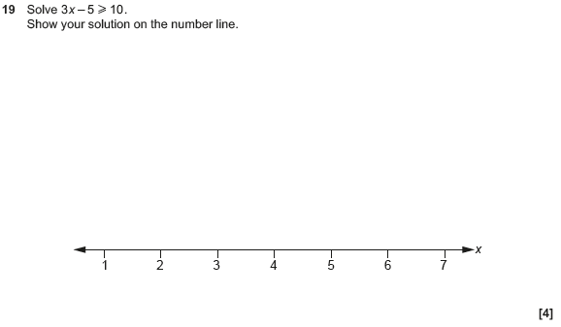

OCR Monday 12 November 2018 – Morning (Calculator) Foundation Tier
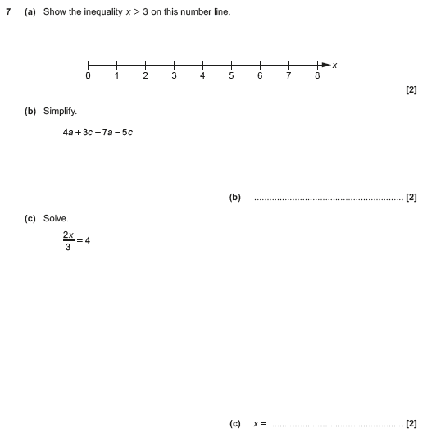

OCR Thursday 7 June 2018 – Morning (Non-Calculator) Foundation Tier
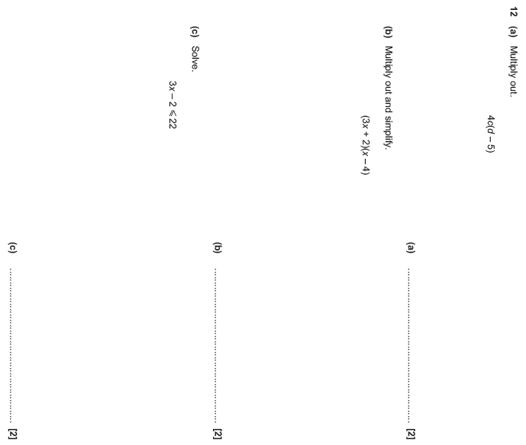

OCR Thursday 2 November 2017– Morning (Calculator) Foundation Tier
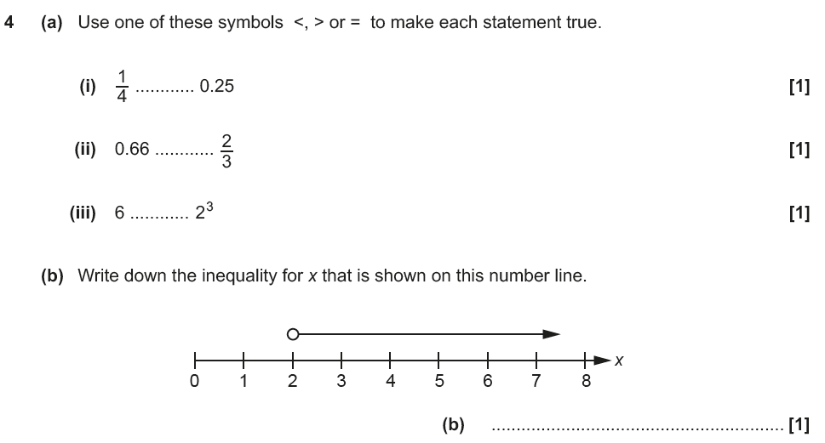

OCR Sample Question Paper 3 – Morning/Afternoon (Calculator) Foundation Tier

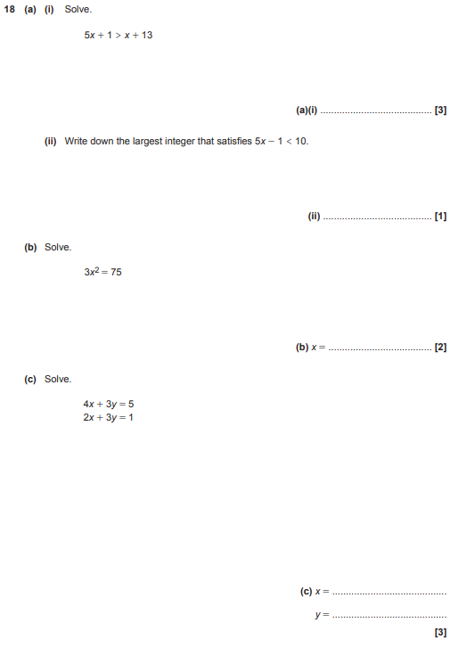

AQA Thursday 6 June 2019 – Morning (Calculator) Foundation Tier

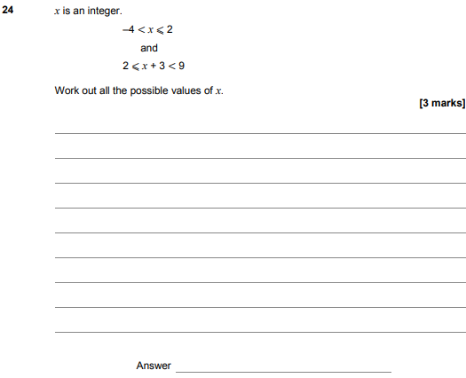

AQA Tuesday 6 November 2018 – Morning (Non-Calculator) Foundation Tier

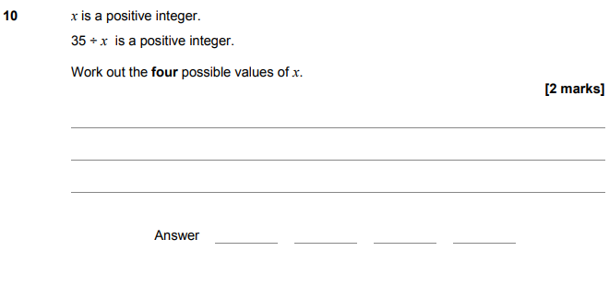
AQA Monday 12 November 2018 – Morning (Calculator) Foundation Tier

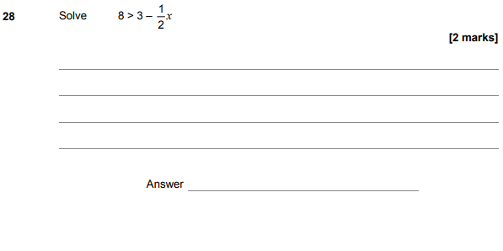

AQA Thursday 24 May 2018 – Morning (Non-Calculator) Foundation Tier

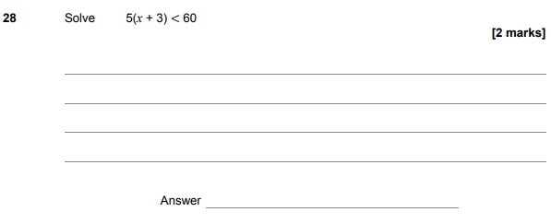

AQA Thursday 2 November 2017 – Morning (Non-Calculator) Foundation Tier

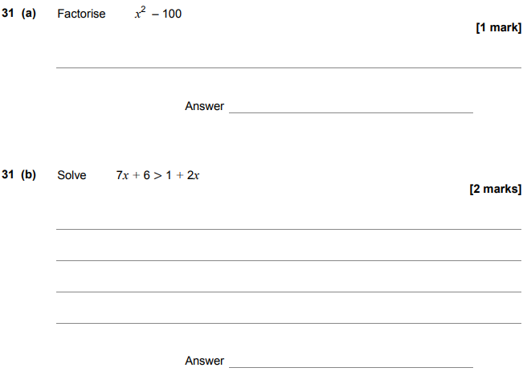

AQA Wednesday 8 November 2017 – Morning (Calculator) Foundation Tier

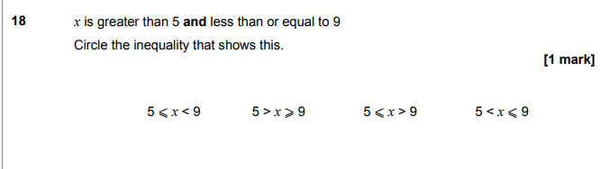
AQA Tuesday 13 June 2017 Morning– Morning (Calculator) Foundation Tier

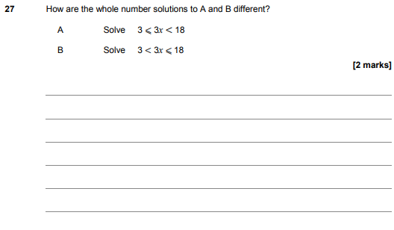

AQA Sample Paper 1– Morning (Non-Calculator) Foundation Tier

